

**Action is the foundational key to all Success……………….!!!**

**ASSIGNMENT-4**

In java the primitive data types are the predefined data types of java. they specify the size and type of any standard values.

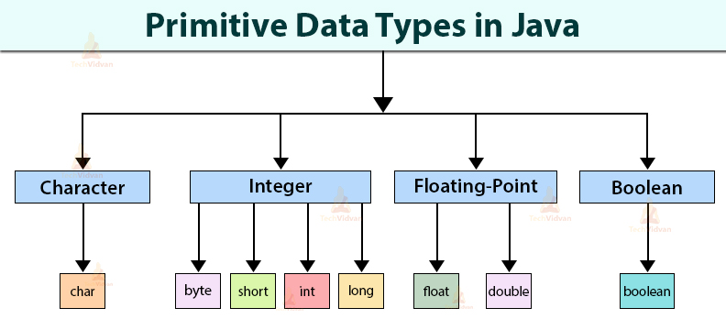

**Table:** flow chart of primitive data type

Now, we need to discuss about the all primitive data types by comparision , its really risking tasks but need to complete with in 11:59pm

come on let’s start now, But its already time up

**Char to char**

We can’t do any type of conversion from char to char

**Char to byte**

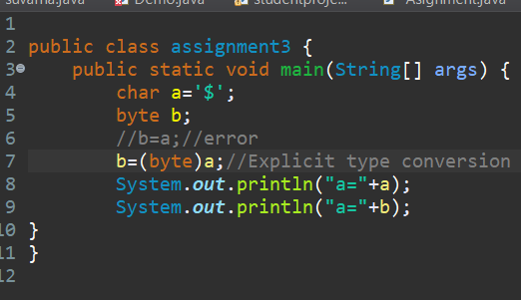

OUTPUT:

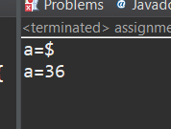

**Char to short**

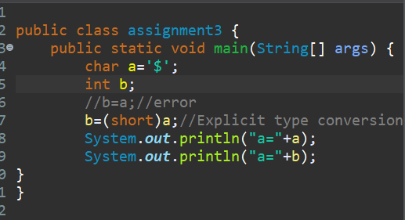



**Char to int**

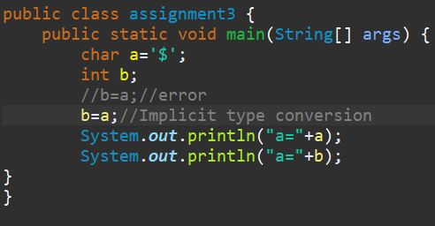

OUTPUT:

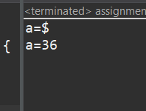

Conclusion: Here we are doing Implicit type casting

**Char to long**

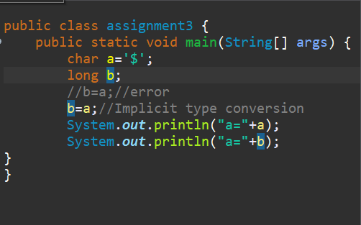



Conclusion: Here we are doing Implicit type casting

**Char to float**

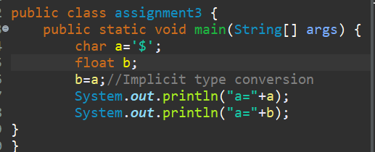



Conclusion: Here we are doing Implicit type casting

**Char to double**

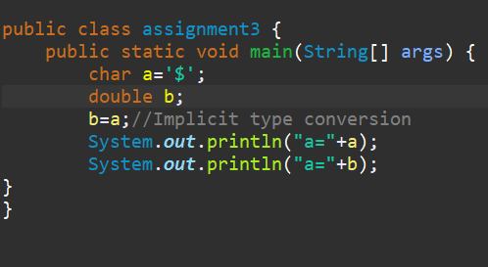



Conclusion: Here we are doing Implicit type casting

**Char to boolean**

We can not convert either to Implicit or Explicit

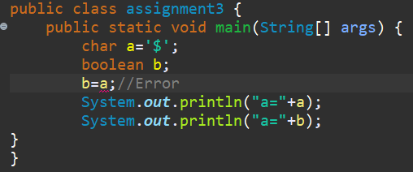

**Byte to char**

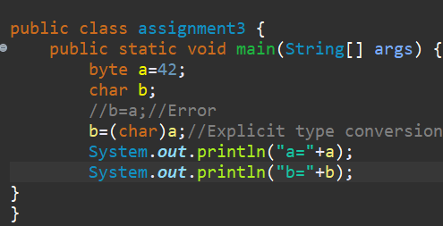

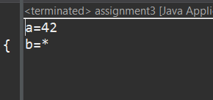

Conclusion : Here we are doing Explicit type casting

**Byte to short**

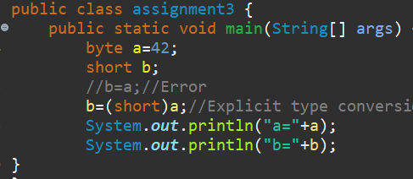

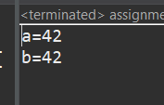

Conclusion: Here we are doing Implicit type casting

**Byte to int**

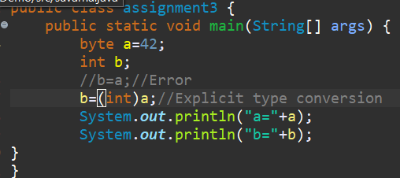

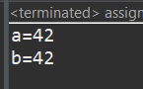

Conclusion: Here we are doing Implicit type casting

**Byte to long**

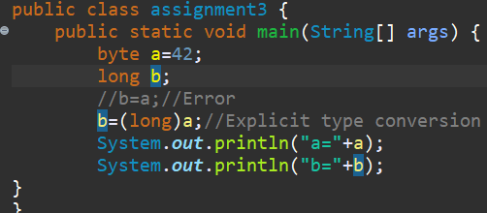



Conclusion: Here we are doing Implicit type casting

**Byte to float**

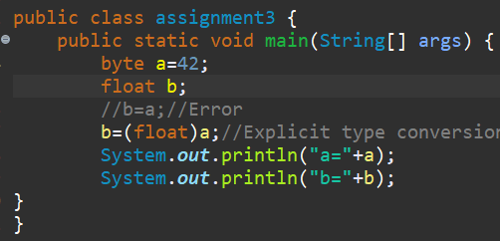

OUTPUT:

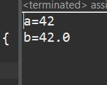

Conclusion: Here we are doing implicit type casting

**Byte to double**

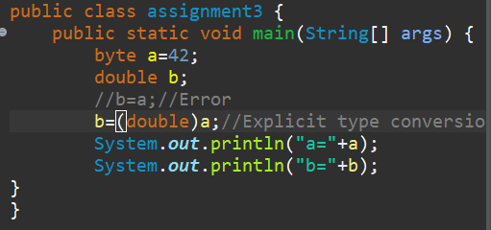

OUTPUT:

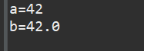

Conclusion: Here we are doing Implicit type casting

**Byte to boolean**

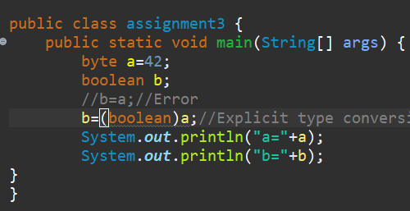

We can not convert either to Implicit type casting.

**Short to byte**

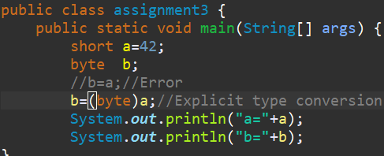

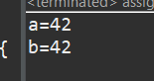

Conclusion:Here we ar doing Explict type casting.

**Short to int**

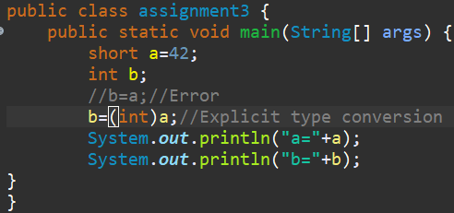

C

Conclusion : Here we are doing Implict typecasting

**Short to long**

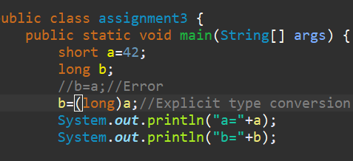



Conclusion: Here we ara doing implicit type casting

**Short to float**

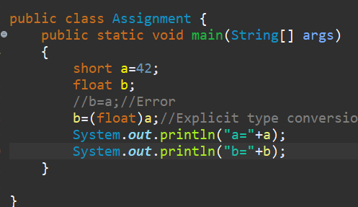



Conclusion: Here we are doing Implicit type casting.

**Short to double**

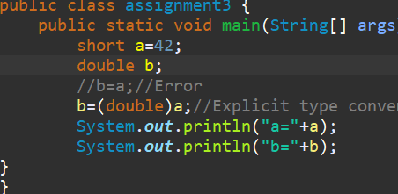

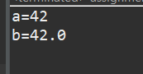

Conclusion:Here we are doing Implicit type casting

SHORT TO BOOLEAN:

We can not convert either to Implicit or Explicit.

**Int to char**

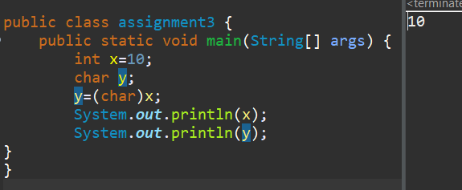

Conclusion:Here we are doing Explicit type castin

**Int to byte**

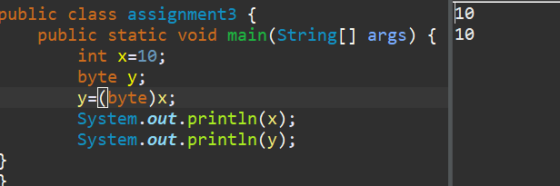

Conclusion: Here we are doing Explicit type casting

**Int to short**

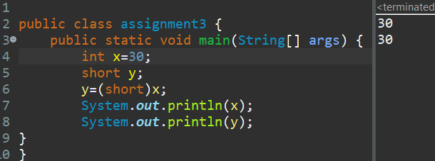

Conclusion:Here we are doing Explicit type casting

**Int to int**

We can’t do any type of conversion from int to int.

**Int to long**

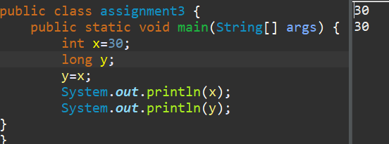

Conclusion:Here we are doing Implicit type casting

**Int to float**

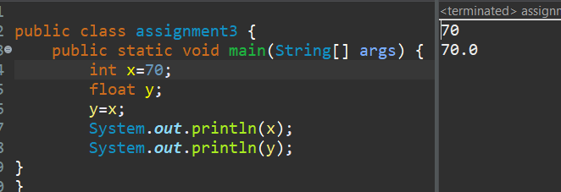

Conclusion: Here we are doing Implicit type casting

**Int to double**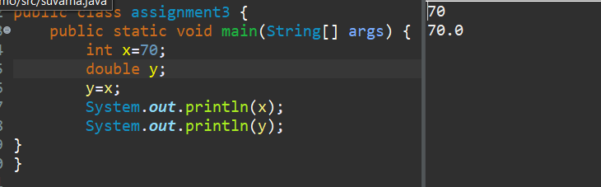

Conclusion: Here we are doing Implicit type casting

**Int to Boolean**

We can not convert either to Implicit or Explicit.

**long to char**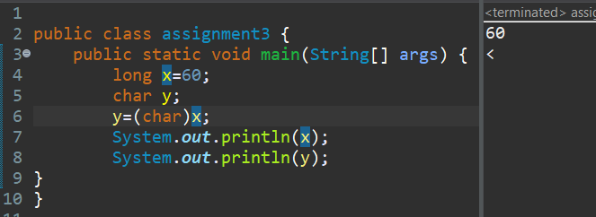

Conclusion: Here we are doing Explicit type casting

**long to short**

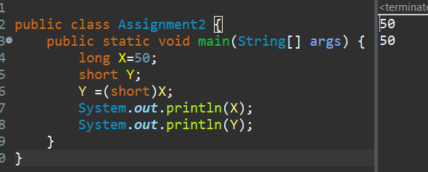

Conclusion: Here we are doing Explicit type casting

**Long to int**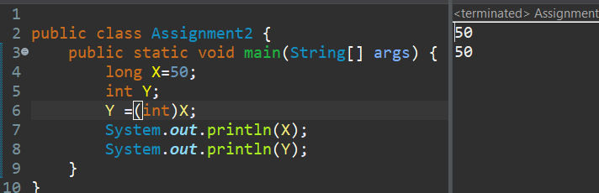

Conclusion: Here we are doing Explicit type casting

**long to long**

We can’t do any type of conversion from long to long

**long to float**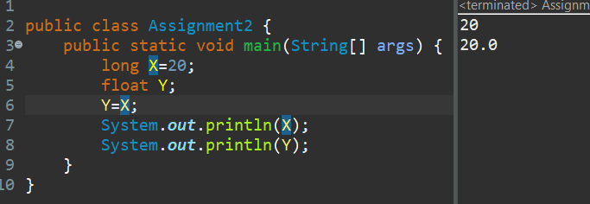

Conclusion: Here we are doing Implicit type casting

**long to double**

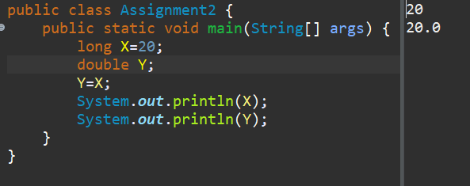

Conclusion: Here we are doing Implicit type casting

**long to Boolean**

We can not convert either to implicit or Explicit.

**float to char**

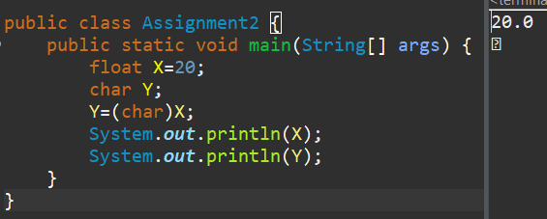

Conclusion: Here we are doing Explicit type casting.

**float to byte**

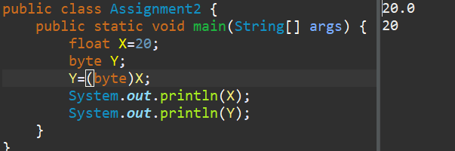

Conclusion: here we are doing Explicit type casting

**Float to short**

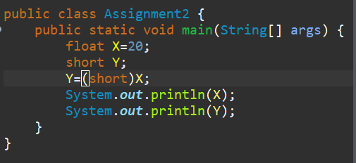

Conclusion : Here we are doing Explicit type casting

**Float to int**

t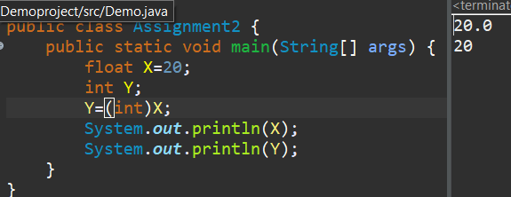

Conclusion: Here we are doing Explicit type casting

**Float to long**

We can’t do any type of conversion from float to float.

**Float to double**

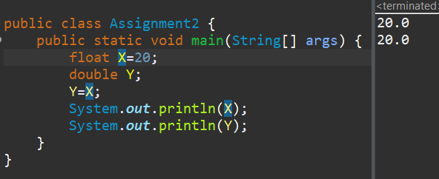

Conclusion: Here we are doing Implicit type casting

**Float to Boolean**

We can not convert either to implicit or Explicit

**double to char**

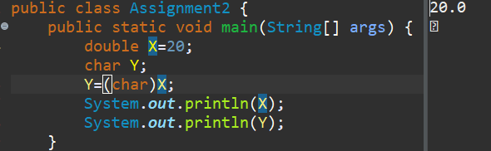

Conclusion: Here we are doing Explicit type casting

**double to byte**

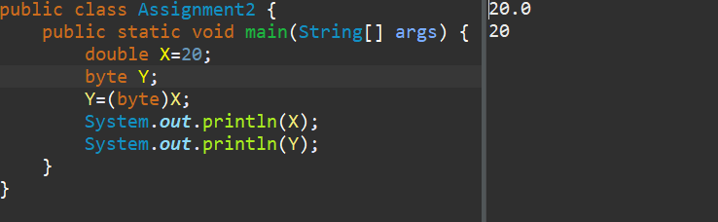

Conclusion: Here we are doing Explicit Type casting

**double to short**

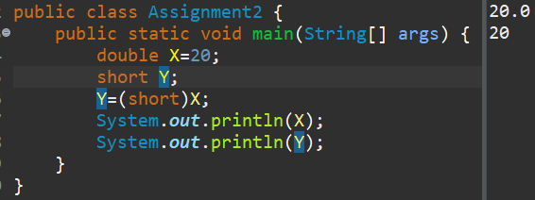

Conclusion: Here we are doing Explicit type casting.

**double to int**

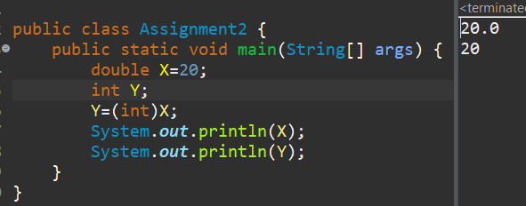

Conclusion: Here we are doing Explicit type casting.

**Double to long**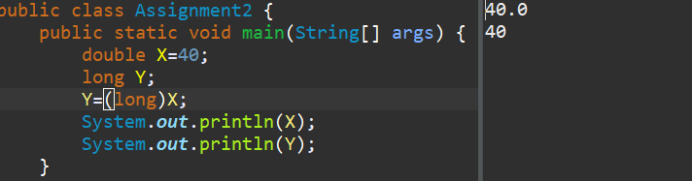

Conclusion: Here We are doing Explicit type casting

**Double to float**

t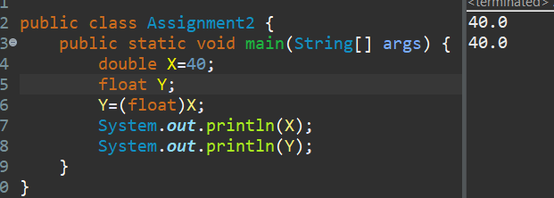

Conclusion: Here we are doing Explicit type casting

**Double to double**

We can’t any type of conversion from double to double

**Double to Boolean**

We can not convert either to Implicit or Explicit.

**Boolean to char**

We can’t do any type of conversion from Boolean to char.

**Boolean to byte**

We can’t do any type of conversion from Boolean to byte.

**Boolean to short**

We can’t do any type of conversion from Boolean to short.

**Boolean to int**

We can’t do any type of conversion from Boolean to int.

**Boolean to long**

We can’t do any type of conversion from Boolean to long

**Boolean to float**

We can’t do any type of conversion from Boolean to float.

**Boolean to double**

We can’t do any type of conversion from Boolean to double.

**Boolean to Boolean** 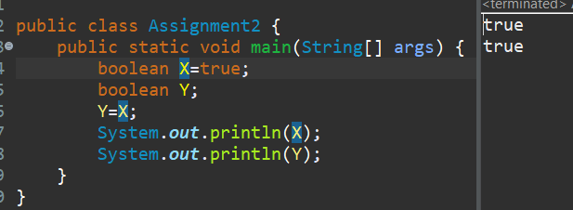

Conclusion: Here we are doing Implicit type casting.

|  |  |  |  |  |  |  |  |  |
| --- | --- | --- | --- | --- | --- | --- | --- | --- |
|  | char | byte | Short | int | long | float | double | boolean |
| Char | NCR | ETC | ETC | ITC | ITC | ITC | ITC | X |
| Byte | ETC | NCR | ITC | ITC | ITC | ITC | ITC | X |
| Short | ETC | ETC | NCR | ITC | ITC | ITC | ITC | X |
| Int | ETC | ETC | ETC | NCR | ITC | ITC | ITC | X |
| Long | ETC | ETC | ETC | ETC | NCR | ITC | ITC | X |
| Float | ETC | ETC | ETC | ETC | ITC | NCR | ITC | X |
| Double | ETC | ETC | ETC | ETC | ETC | ETC | NCR | X |
| Boolean | X | X | X | X | X | X |  | NCR |

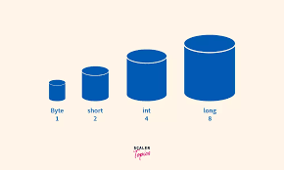

I hope I have done to best of my Knowledge .Thank you sir